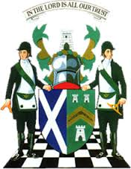
The Grand Lodge of Antient Free and Accepted Masons of Scotland
William Ramsay McGhee, M.St.J., D.L., Grand Master Mason
8 May 2020
Brethren
Today we mark 75 years since VE Day – a day for all of us to remember and to give thanks to all those who gave their all, thereby allowing us, over the past 75 years, to have the freedom to enjoy our Freemasonry and all other pursuits that we participate in. Many Scottish Freemasons from our Lodges at home and abroad paid the ultimate sacrifice. The words of John Maxwell Edmunds say so succinctly - “When you go Home, tell them of us and say, for your Tomorrow, we gave our Today”
As a result of Covid-19, the many VE Day celebrations planned for today will no longer happen, but I ask that you pause at some point today in remembrance of them.
And as the death toll at home continues to rise as a result of Covid-19 let us also remember those who have died as a result of this unseen enemy and keep in our thoughts the families of those who have died.
As we approach this weekend and with a forecast of good weather, we should have been looking forward enjoying The Abseil Event off the Forth Rail Bridge on Sunday. This would have seen 36 brethren and 1 lady from 28 provinces all over Scotland taking part in a fundraising event to support our nominated charity Prostate Scotland. The brethren and their supporters did exceptionally well to raise over £20,000 in the short time before the lockdown. Regrettably, the event has been postponed due to the current health emergency but hopefully it will not be long before the participants are able to complete their challenge and help the charity in its essential work for men in Scotland.
Last Saturday, I was delighted to participate in the second conference with 21 of our 26 District Grand Masters. Irrespective of where our Scottish Lodges are situated, they have all suffered at the hands of Covid-19 in some way or another. It was good to get updates from each District and hear directly what conditions are like for everyone. My sincere thanks to all who participated and to Brother Jarmakani for making all the necessary arrangements.
I mentioned last week that two of our Provincial Grand Masters were setting up a new Facebook page dedicated to all the assistance that our Provinces / Districts / Lodges , Individual Brethren have given in so many ways to their fellow Brethren and their families but equally important, to the communities in which they operate. There has been an excellent uptake for the page, but I would like to encourage our Brethren in the District Grand Lodges to participate as well. I learned last Saturday that all our Districts are doing amazing work in their communities. So please, Brethren, share your efforts with us – we would be delighted to know what Scottish Freemasons are contributing to their various communities throughout the world. The direct link is-
https://www.facebook.com/groups/Scottish.Constitution.Freemasonry.Supports/
Please remember for any urgent issues whether at home or abroad – you can contact Grand Lodge on the following numbers - Dawn Oliff - 07464 683630, Sue Williams 07881 440272 and Andrew Paterson 07787 217772. Emails to Sue at pa@grandlodgescotland.org will also be picked up and forwarded to the correct person.
Please take care of yourselves and each other – stay safe.
Kindest regards to you all.
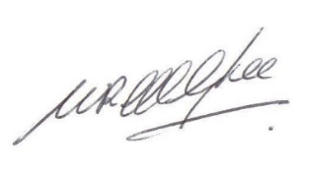
Ramsay McGhee
Grand Master Mason

