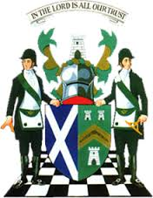
The Grand Lodge of Antient Free and Accepted Masons of Scotland
William Ramsay McGhee, MStJ, D.L., Grand Master Mason

Brethren
As I mentioned last week, I have written to the Scottish Government seeking clarity and guidance in respect of the opening of Lodges and the use of Lodge buildings. I have received acknowledgement from the Government that they have received my letter but, so far, no full response. I will update you all as soon as I receive a response.

That said, it is looking more and more unlikely that we will be able to carry out the Rededication of Lodges scheduled to take place between September and December. Accordingly, I am in the process of rescheduling all the meetings into 2021. Once this exercise is complete, I will be in touch with all the Lodges involved to discuss proposed new dates. It is extremely important that we celebrate our Lodge anniversaries and I am determined that, despite the problems posed by Covid-19, we will carry out all ceremonies as soon as it is safe to do so.

Latest news from the Scottish Constitution Freemasonry Supports Facebook page is as follows –
https://www.facebook.com/groups/Scottish.Constitution.Freemasonry.Supports/

Last week This week
Members 2863 2934
Posts 299 322
No of Members posting 161 169
Lodges mentioned 176 177
Provinces mentioned 29 29
Districts & Lodges abroad 11 11
Monetary Value £214,170 £226,970

Brethren, this reflects the tremendous work being carried out by Brethren throughout the Scottish Constitution – over quarter of a million pounds in twelve weeks. On top of the monetary aspect, I am well aware of the diverse range of other contributions being made to communities ranging from delivery of food and medicine to the housebound to organising blood donor sessions and a plethora of other activities in between. My sincere thanks to you all.

Interest in the SCFS page remains at a very high level as more and more of our Overseas Brethren become aware of it and subscribe into its current raison d’être. We all look forward to receiving posts from our Lodges in the Districts and would strongly encourage our Overseas Members to maintain the excellent frequency and quality of their submissions to the group.

We had 31 Brethren added this week bringing our Overseas Membership of SCFS to 589. We are well on target to break the 600-barrier next week.

We had new members join from Bahamas, Bermuda, Central South Africa, Far East, Fiji, Jamaica, Mauritius, Middle East, Trinidad & Tobago and Grenada. The largest increase was seen in the District of the Far East and, in addition, there was an encouraging number of new members from our only lodge in Fiji ... Lodge Polynesia, No. 562. Following is an overview of our Overseas Membership numbers -

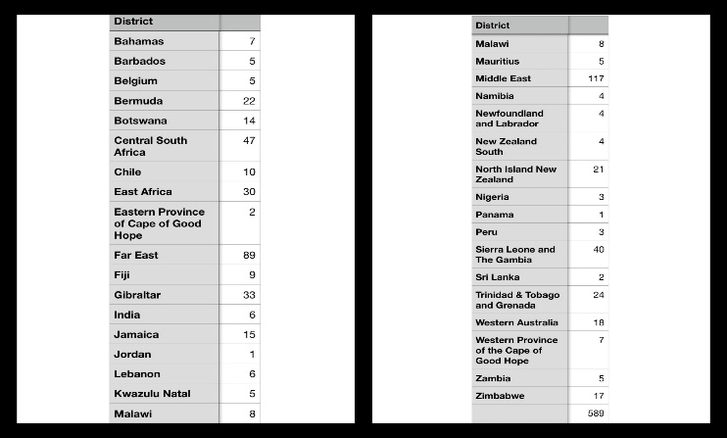

Last Saturday I was delighted, once again, to meet via zoom with our District Grand Masters. We had 31 on the call which included a few DG Deputes, Substitutes and Secretaries but this time round we had seven Districts not represented for various reasons. While we received some very positive reports, unfortunately, the Covid-19 situation was not so good with a number of countries in Africa and much of India reporting escalating cases of the virus. It served as a timely reminder to us all that this virus is still very much alive and kicking. Our thoughts and prayers are with all those who are facing escalating cases of the virus.

It is being planned that our next monthly District Grand Masters meeting will be a joint meeting with the Provincial Grand Masters.

On a much happier note, collectively, we were able to pass on our heartiest congratulations, through her husband, Brother Joe Currie, to Mrs Terez Currie who has received the prestigious Commonwealth Point of Light Award for her amazing work with the Red Cross in respect of both the Covid-19 pandemic and her work following Hurricane Dorian. I’m sure, through this update, you would all wish me to convey the sincerest congratulations of the Grand Lodge of Scotland to Mrs Currie.

Can I remind all Brethren who would like to participate in the Grand Lodge of Scotland Clay Shooting Championship to be held on the 16th August at the National Shooting Centre to contact the organising committee on either gloscsa@gmail.com or gloscsa@aol.com. Alternatively, you can make contact through the Scottish Masonic Clay Championships Facebook page.

Brethren, as we enjoy the easing of restrictions, please stay alert, look after yourselves, your families and the Brethren who are in any of the vulnerable categories.

Kindest regards
Ramsay McGhee
Grand Master Mason

