30 March 2020

NOTE T0: GRAND LODGE OF SCOTLAND PROVINCIAL & LODGE SECRETARIES
AND GRAND COMMITTEE MEMBERS

Brethren

Subsequent to the update that Sue circulated for me on Saturday, I have had two very helpful responses from two Brethren which I would ask you to circulate to your various Lodge and Club Committees. First from Brother Ian Christie regarding –

Unoccupied Offices and business premises during the COVID-19 national emergency.
Are you covered?

This is an extremely difficult time for businesses, and it is imperative that some guidance is given. The current coronavirus COVID-19 pandemic has raised questions about the extent of insurance cover.

Many offices and businesses up and down the country are now sitting empty. The virus pandemic in the UK has seen strict Government orders to avoid social contact in a nationwide effort to combat the spread of the virus, with people without exception being asked to work from home and many commercial premises temporarily closed.

Buildings whether temporarily closed or permanently unoccupied can be at greater risk from theft, escape of water, arson or vandalism.

There are various definitions of unoccupied commercial premises typically:

“When the premises are closed for a consecutive number of days specified in their insurance policy ………………….”
If you have closed your business premises, the good news is that certain insures have automatically extended cover to clients who have followed Government advice to close their premises temporarily for a period of up to 90 days but you should check with your Insurers/broker/agent to ensure your policy has been correctly adjusted.

Please note that not all policies will automatically cover all business equipment taken home from the main business premises although some insures have extended cover to provide the same level of protection whilst normal business activity is carried on at the homes of employees.
TIPS
- Secure the premises. Ensure that for security reasons intruder alarms are set in accordance with the policy requirements.
- Turn off the water supply. In empty properties leaks are less likely to be spotted early.
- Ensure fire alarms are working remotely.
- Visit the premises as often as possible but following the latest Government guidelines on travel.

Secondly, Bro Robert McMillan, Secretary of Lodge Easterhouse 1591 has been in talks with their brewers, Tennants, and they have agreed to replace any full barrels that may go out of date by the time the Lodge reopens. It could be worthwhile other Lodges checking stock dates and negotiating with their respective suppliers.

Yours sincerely and fraternally
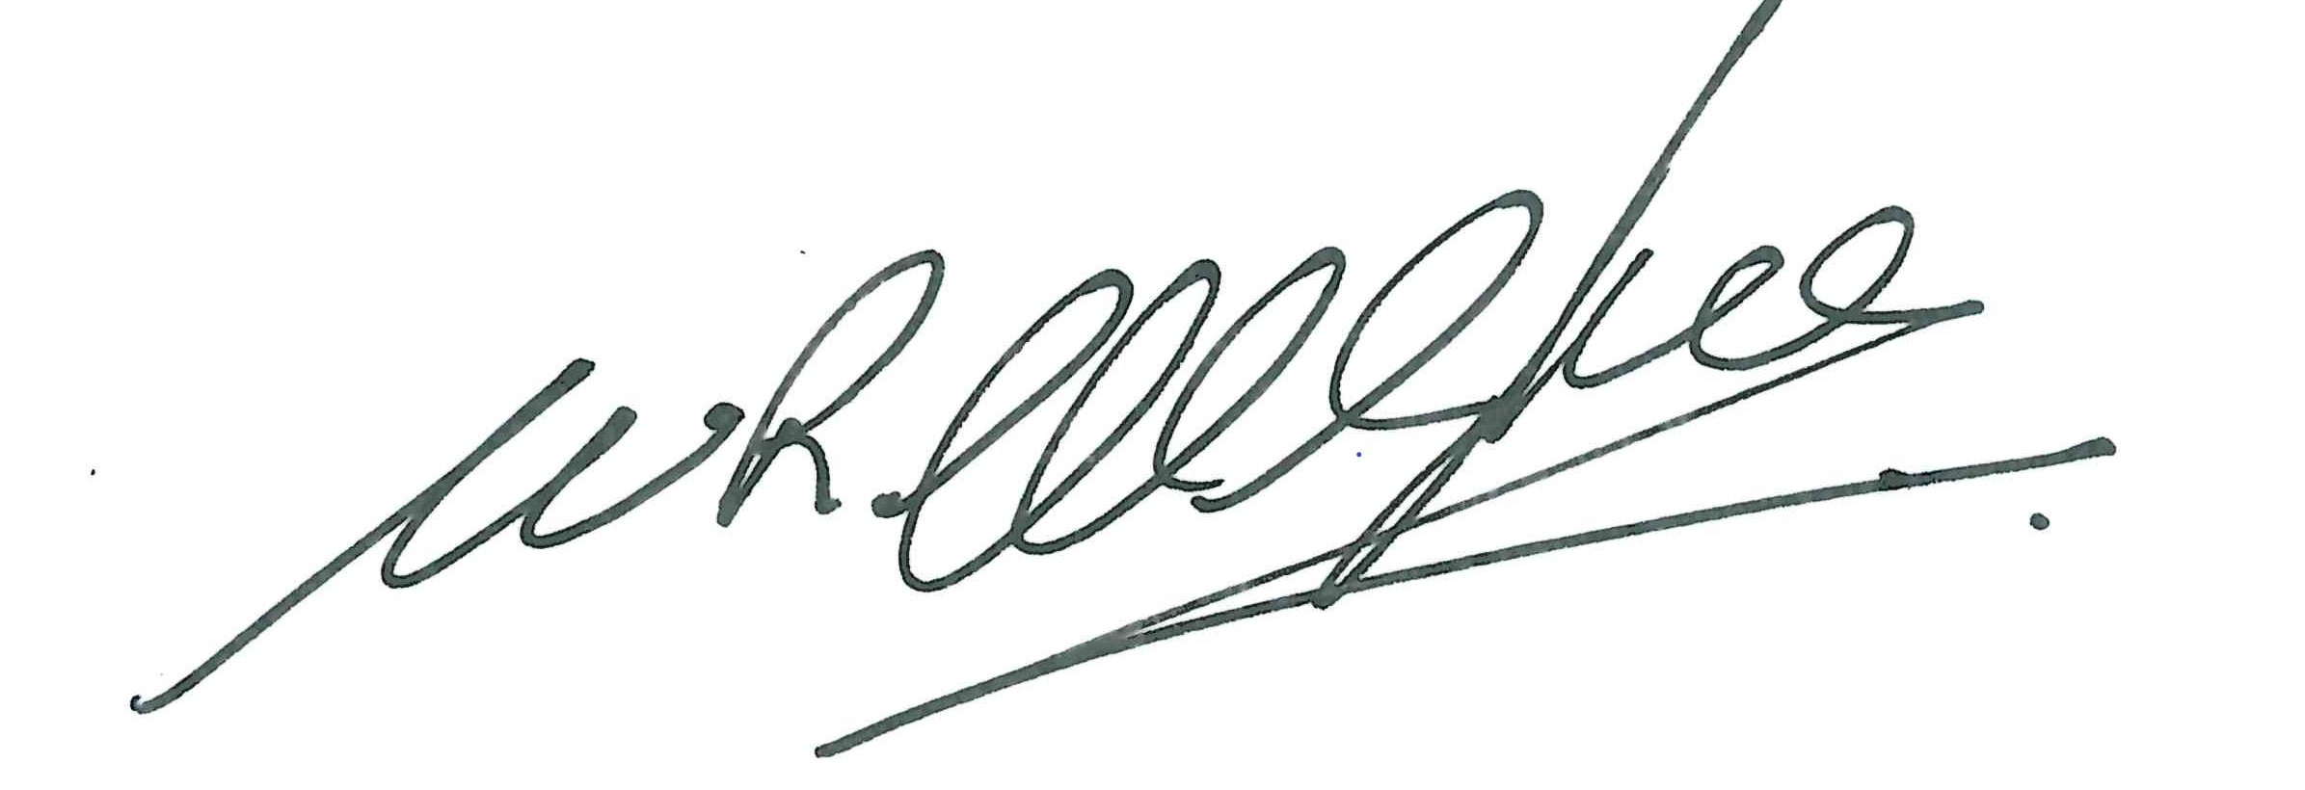

Ramsay McGhee
Grand Master Mason

